Name _____________________

Date_____________________

Luxilus chrysocephalus
Striped Shiner

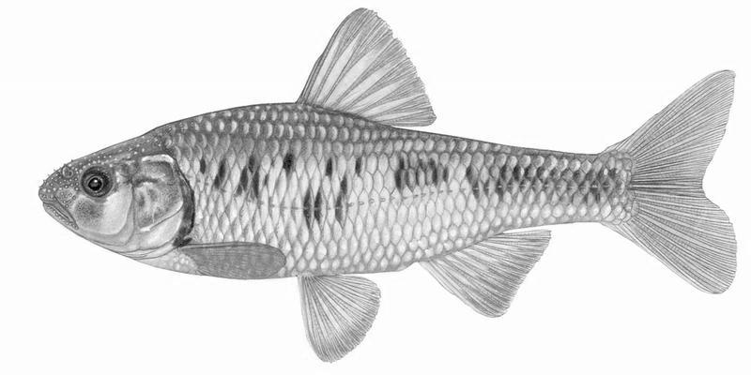
Draw a line and label each part of the fish from the list below. Be sure to use arrows to identify small parts.

Caudal Fin
Lateral Line
Anal Fin
Caudal Peduncle
Ray
Tail

Head
Trunk
Nostril
Eye
Mouth

Operculum/Gill Flap
Pectoral Fin
Opercular Aperture
Pelvic Fin
Dorsal Fin

