Name _____________________

Date _____________________

Micropterus dolomieu
Smallmouth Bass

Draw a line and label each of the parts of the smallmouth bass listed below. Be sure to include arrows for small points of identification.

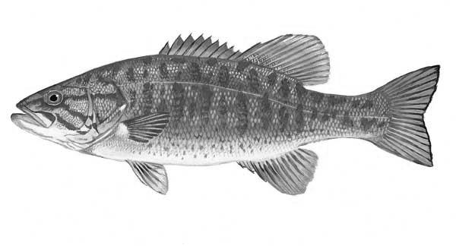

Pectoral Fin
Caudal Fin
Tail
Maxilla
Head
Back Dorsal Fin

Mandible
Cnetoid scales
Pelvic Fin
Front Dorsal Fin
Peduncle
Lateral Line

Shallow Interdorsal
Notch
Operculum/Gill Flap
Eye
Ray

